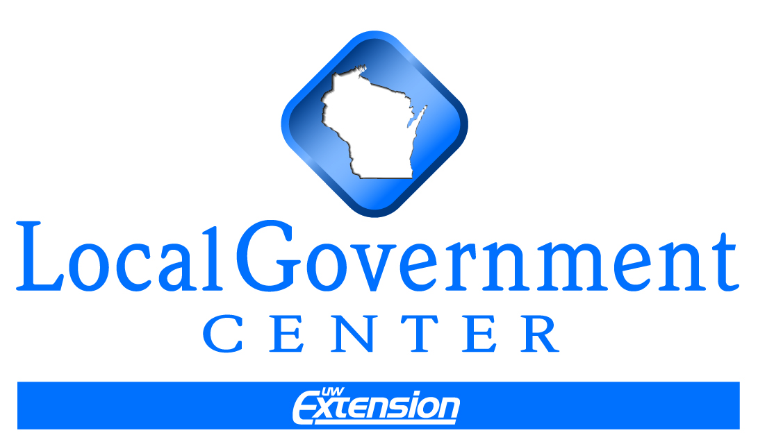

Basic Review of the Property Tax for the City of Galesville

The property tax is a major source of general revenue for local governments, which include counties, towns, cities and villages. General revenues are used to finance day-to-day operations and typically do not limit spending to certain items or activities. Taxes, some state/federal aids, intergovernmental charges, fees, penalties, and interest comprise general revenues.
In Wisconsin, the property tax is really the only tax that local governments can use in raising their general revenues. Municipalities can enact a wheel tax. Municipalities can also enact a room tax, but can only retain 30% for government operations.

Property Tax Share of Revenues
The property tax is very important to local governments. In 2008, the property tax made up about 38% of the general budget for Galesville. This figure would be higher if debt was not included in total revenues.

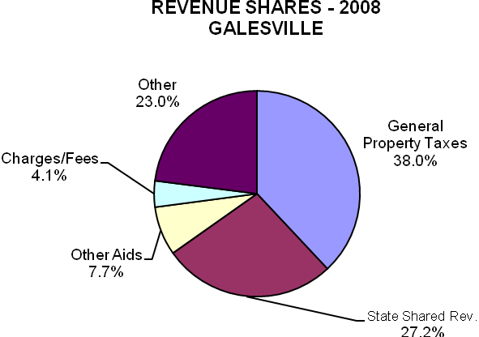
Figure 1. 2008 Revenue Shares for the City of Galesville.

Besides local governments, schools and technical college districts rely heavily upon the property tax for their general operations. On average, Wisconsin schools rely upon the property tax for 37% of their revenues and technical college districts for 44% of their revenues. The chart summarizes reliance on the property tax (the average percentage for each category).
Use of Property Tax
Counties 30%
Towns 29%
Villages 26%
Cities 28%
Schools (K-12) 37%
Technical Colleges 44%

“Other financing sources” includes monies from debt and refunding debt, interfund transfers, and sales of major assets. This category makes up 39% of town revenues, 41% of village revenues and 29% of city revenues. Use of general fund transfers, sales of fixed assets, and the greater use of debt are being employed by local governments to meet their needs and to address rising costs under the property tax levy limit.

Property Tax Bill: Use and Pressure

State and Local Taxes
In fact, the property tax is the largest tax in Wisconsin. Like most states, Wisconsin relies upon what are considered the “big three” taxes in financing services: property tax, income tax and sales tax. Unlike other states, however, Wisconsin has assumed central collection authority of the income and sales taxes, reserving the property tax for local governments to use and collect. The state redistributes roughly 60% of general fund collections back to local governments and schools in the form of state aids (i.e., shared revenue, general education aids, etc.). By contrast, other states allow local governments to impose a sales and/or income tax in addition to the state sales and income tax. The table below shows Wisconsin’s state tax collections for the income and sales taxes between 1960 and 2008 and local collection of the property tax.

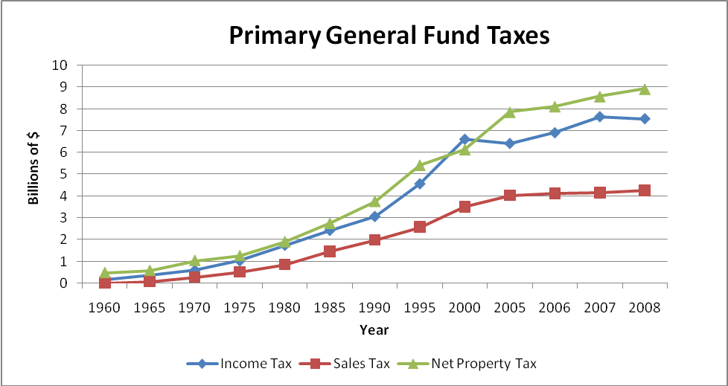
Figure 2. Primary General Fund Taxes in Wisconsin, 1960 – 2008.

Property Tax Bill View: Location, Location, Location!

Your property tax bill is going to look different depending upon where you live (town, city, village). For example in towns, the “local” tax is going to be smaller with a greater portion going to the county and school districts. Galesville’s city tax made up 27.4% of the tax bill for Galesville city residents in 2008. The school tax comprised another 37.1%, the county tax 23.2%, technical college tax 7.8%, and other taxes made up 4.6% (See Figure 3).

Tax Basics

There are certain basics that you examine in any tax: (1) levy or amount of tax, (2) what items are taxed (base), and (3) the rate of taxation. Of course there are other considerations in tax policy, such as ability to pay and equitable application of the tax. Still, understanding these three factors will help you better understand the tax. In the case of the property tax:
- The tax base is the value of taxable property in a community. Some property is exempt from taxation.

Figure 3. 2008 Galesville Property Tax Distribution.

2. The tax levy is the portion of a local government’s budget that will be financed through the property tax.
3. The tax rate is simply the result of the relationship between the amount needed for the property tax levy from the taxable property in the community. The rate, often called a “mill rate,” is expressed in terms of a property tax dollar amount per thousand dollars of value. Example: A property tax rate of .005 is $5 of property tax per $1000 of value. So, if my home is valued at $100,000, then my property tax would be $500 (.005 x $100,000). Or, there are 100 thousands’ in 100,000, so $5 x 100 = $500.

There are important relationships between the

Property Tax Levy = Property Tax
Property Value Rate

If property values ↑ and the levy stays the
same, the rate will ↓
If property values ↓ and the levy stays the
same, the rate will ↑

amount needed by local governments (levy), the
value of taxable property in the community (base) and the tax rate.

Increasing property values or growth in the community’s tax base with the community
levying the same amount as the prior year will
result in a decrease in the property tax rate.

Conversely, declining property values or a reduction in the community’s tax base will increase the tax rate even if the community levies the same amount as the prior year. These relationships are not usually so simple (i.e., one component remaining the same while the other two factors change). Increases or decreases in the rate depend upon the relative increases/decreases in the property tax levy and in property values.

Property Tax Rate
The rate is just a function of what is happening to the property tax base and the amount needed by local governments for their operations. So any changes to the rate will focus inquiry on what is happening to the tax base and to the levy.
Why is there such a fuss about the rate?
Property owners focus on the rate since this factor determines how much they will pay per $1000 of property value.

To begin our examination, let’s see what the property tax rates have been doing between 1990 and 2008 in Galesville. The graphs below show property tax rates have been decreasing for Galesville and other small cities. Galesville’s rate peaked in 1991 at $10.83 and decreased to $6.81 in 2008 (Figure 4). These figures are all in 2009 dollars, thus controlling for any effects of inflation.

Tax Base
On average, property tax rates for local governments have been declining since at least 1992. What does this mean? Do Galesville and other local governments need less money for operations and are thus lowering tax levies? Are property tax bases growing because of increasing values? Let’s look at the property tax base first. The pie charts below show how the tax base has changed statewide between 1960 and 2009.

Essentially the tax base has gone from 50% residential property to 72% residential property statewide between 1960 and 2009 (includes “other" property which is farm residences and buildings). The tax base was far more diverse in 1960 than in 2009, with commercial, manufacturing, agricultural and personal property making up relatively equal portions of the other 50%. In 2009, commercial and residential property made up 92% of the tax base. Many factors contributed to this substantial change in tax base.

Galesville has also seen a shift in its tax base. In 1990, residential property made up 61.1% of the tax base. By 2009, residential property had increased to 76.8% of the tax base. Decreases were seen in commercial property (from 16.1% to 14.9%); personal property (from 7.8% to 2.8%); and manufacturing property (from 15% to 5.5%). Refer to figure 5. Trempealeau County cities on average had 60% of the tax base comprised of residential property in 1990 and 63% in 2009.
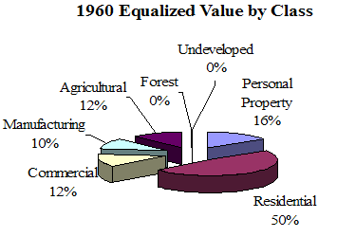

Figure 4. Local Tax Mill Rate from 1990 through 2008 for Galesville and all other Wisconsin Cities below 2,500 people.

Manufacturing has declined since 1960 and some tax base exemptions were enacted to boost this part of the state’s economy. There have been similar exemptions for personal property. Agricultural land, agricultural forest, and undeveloped land have reduced valuations to counter the speculative forces that increase the value of these lands beyond their productive use. Residences on average are larger; fewer people inhabit them, more

Figure 5. Equalized value by class in Galesville.

Property values have also increased since 1990, as shown in Figure 6. This graph indicates that total equalized value increased 330% in Galesville between 1990 and 2008. Perhaps a more concrete way to see the change in property values is to look at the per capita values for the city between 1990 and 2008. Per capita values in Galesville went from $13,996.91 in 1990 to $53,859.60 in 2008.

There have been shifts in the property tax base over time and property values have increased fairly significantly in the past 16-18 years. So, if property tax rates are falling and property values are increasing, what has been happening with property tax levies?

Figure 6. Total Equalized Value Index for the City of Galesville. An index is a way to look at percentage increases.

Local Property Tax Levies
Galesville’s property tax levy increased 257% between 1990 and 2008. During the same period, Trempealeau County’s property tax levy increased by 262%. Trempealeau County town levies increased by 151%; city levies increased by 258 % (all cities in the county); and village levies increased by 454% during this same period. It appears that property tax levies also increased significantly during this time. The property tax rates, however, have decreased since 1991. What does this mean? In relative terms, property values increased at a higher rate than property tax levies. See the summary table below to see this in numerical terms.

Figure 7. Total Equalized Value per Capita in the City of Galesville, 1990-2008.

% Changes in Property Tax Elements
1990-2008
Trempealeau County | % Rate  Change | % Change in  Property Value | % Change in Tax Levy
City of Galesville | -$4.02 or -37% | 330% | 257%
County | -$1.65 or -21% | 374% | 262%
Town | -$2.04 or -25% | 369% | 151%
City | -$0.97 or -12.5% | 343% | 258%
Village | -$0.68 or -8% | 514% | 454%

For all local governments, the increase in property values exceeded the increase in property tax levies. For example, county property values increased 412% 1990 and 2008, but levies increased 274%. Local efforts to “increase tax base” focus on these relationships between the rate, levy and tax base (property value). Property values in Galesville increased 330% between 1990 and 2008; however, the tax levy only increased 257%.

Summary
This paper explains the basic elements of the property tax and their relationship to one another, property tax usage by local and special governments, and the place of the property tax in state/local finance. The property tax is an important part of local revenues, but it is not the only component. State and federal aids make up an equally significant, if not greater, portion of local revenues. Increases in property taxes often reflect stagnant to declining revenue sources along with increased costs of providing services. Focus on the property tax is due to its unpopularity, its high usage, and its use to make up for revenue shortfalls and increased costs.

Resources
The Local Governance and Finance team conducted a November 2006 in-service on the property tax called Property Tax 101 and 102. The program recording, along with all program materials are available at https://www.uwex.edu/ces/apps/lgc/index.html which is under UW Extension Staff and Educator on the Local Government Center’s website at http://lgc.uwex.edu This is secured access, so you will need your username and netid to access this page.

The Legislative Fiscal Bureau develops informational papers every two years at the beginning of each budget cycle. The following papers may be of interest to you at http://www.legis.state.wi.us/lfb/Informationalpapers/info.html

Local Government Expenditure and Revenue Limits (Informational Paper 12)
Property Tax Level in Wisconsin (Informational Paper 13)
Property Tax Administration (Informational Paper 14)
Local Government Revenue Options (Informational Paper 15)
Municipal and County Finance (Informational Paper 16)
Tax Incremental Financing (Informational Paper 17)
Shared Revenue Program (County and Municipal Aid and Utility Aid) (Informational Paper 18)
Targeted Municipal Aid Programs (Expenditure Restraint and Computer Aid) (Informational Paper 19)
Payments for Municipal Services Program (Informational Paper 20)
State Property Tax Credits (School Levy, First Dollar, and Lottery and Gaming Credits) (Informational Paper 21)
Property Tax Deferral Loan Program (Informational Paper 26)

The Department of Revenue has a number of publications and reports that involve the property tax:

Town, City and Village Taxes at http://www.dor.state.wi.us/pubs/slf/tvc09.pdf Note that this data is in the GREAT software.

Net New Construction Report at http://www.dor.state.wi.us/equ/nnc.html Note this is updated each year.
Statement of Changes in Equalized Values at http://www.dor.state.wi.us/equ/report2.html Note this is updated each year and provides historical information by category of property, and percentage changes due to new construction and to property value growth/decline for every county and municipality. This data is also in the GREAT software.
Wisconsin State and Local Taxes FY 87 – FY2006 at http://www.dor.state.wi.us/ra/07taxwi.pdf
A Property Tax Guide for Mobile Home Owners (2/08)
Agricultural Assessment Guide for Wisconsin Property Owners (1/10)
Government Program and Eligibility for Use-Value Assessment
Guide for Board of Review Members (1/10) -- See the Board of Review FAQs
Guide for Property Owners (4/10)
Guide to the Property Assessment Process for Wisconsin Municipal Officials (12/04)
Property Assessment Appeal Guide For Wisconsin Real Property Owners (4/10)

There is also a Frequently Asked Questions Page on the Department of Revenue Website:

Ag Forest & Undeveloped Land
- Qualifying Parcels
- Ownership
- Roads and Similar Issues
- Valuation of Agricultural Forest and Undeveloped Land
- Undeveloped Land
- Miscellaneous

Board of Review
- Filing Objections/Forms
- Scheduling Objections
- Hearings/Proceedings
- Removal of Members
- Decisions

Other
- First Dollar Credit
  - Sample Property Tax Bill
  - How to Calculate the First Dollar Credit
  - First Dollar Credit and Related FAQs
- Levy Limits
- Lottery and Gaming Credit
- Manufacturing Assessments
- Property Assessments in a Declining Market
- Real Estate Transfer and Merger/Conversion
- Tax Incremental Financing
  - Frequently Asked Questions
- Telecommunications Property Tax
- Use-Value Assessment
- Use-Value Conversion Charge
- Waste Treatment Exemption

Finally, the Executive Budget and Finance Office in the Department of Administration each year puts out a number of reports, including the annual fiscal report. This report provides basic summary information on state taxes and expenditures.

State Fiscal Year Ended June 30, 2009 (PDF)
Appendix to 2009 Report (PDF)

This report was based on a report prepared by Kate Lawton, UW-Extension Local Government Center. It was customized for the City of Galesville by Pat Malone, Community Development Educator, UW-Extension Trempealeau County.

October 26, 2010

