What is the GREAT Mapping Software?
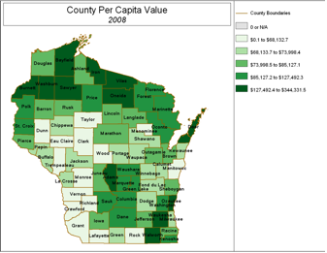
The GREAT Mapping application allows users to view the information contained in GREAT in a map format. The application is a lightweight viewer designed for examining distributions of data rather than for use in more advanced mapping or geospatial analyses. For users wishing to use this information in other GIS software, the tables and geospatial data are available by contacting Matt Kures at (608) 265-8258. Note that the mapping application is a beta version and some bugs may still exist. To report issues or make suggestions for future releases, please contact Matt Kures.
Note: The GREAT Mapping software will not run on 64-bit operating systems. This does not preclude any operating system such as Windows 7, Vista, or XP, as these have 32-bit versions. The file is approximately 310 Mb; with a 1 Mb internet connection, it should take you about 5 minutes to download the application.
To access the GREAT Mapping application:
- Download the file at the following link: https://mywebspace.wisc.edu/mekures/greatmapping.zip
- Create an empty folder somewhere on your computer and extract the files in the zip file to the folder
- Double-click the “setup.exe” file and follow the instructions on the screen
Download the GREAT Mapping Software Reference Guide( PDF file, 692 kb) for more information on how to use the software.

