Effective Electronic Public Meetings – Part 1

The Basics

February 24, 2021 –10:00 to 11:00 am

The League of Wisconsin Municipalities and the UW Madison Extension, Local government Education Program have teamed to present two webinars on Electronic Meetings. The Part 1 will cover the basics to keep your electronic meeting compliant with the Wisconsin open meeting law.

Part 2 will delve into addition advanced issues and all participants can submit ahead of time their specific questions to our expert panel.

Speakers: Paul M. Ferguson, Assistant Attorney General, Wisconsin Department of Justice, Office of Open Government and Andrew T. Phillips, Attorney, von Briesen & Roper, S.C., outside general counsel for the Wisconsin Counties Association. Philip Freeburg, Law Educator and Distinguished Lecturer, UW Madison Extension, Local Government Education Program.

Assistant Attorney General Ferguson will provide an overview of DOJ's guidance on the applicability of the open meetings law during the current pandemic. This overview will include the DOJ Office of Open Government advisories and address some reoccurring issues encountered by those attempting to ensure compliance with the open meetings law using an electronic (virtual) meeting format.

Attorney Phillips will discuss the practicalities of how local governments can best follow the state guidelines for electronic meetings. In-person meeting safety issues and concerns and reasonably accessible meetings.

Attorney Philip Freeburg will review the importance of Electronic Meeting Rules Policies and provide Electronic Meeting tips, including mixed meetings and accommodations

The presentation materials will also include a list of electronic meeting platforms as part of the registration materials.

This webinar's price is $20.00, and please use this LGE registration link to sign up, https://charge.wisc.edu/LocalGovernment/workshop_register.aspx?workshop_id=53 . After registering, you will receive an email with a Zoom link that will allow you to complete your webinar registration.
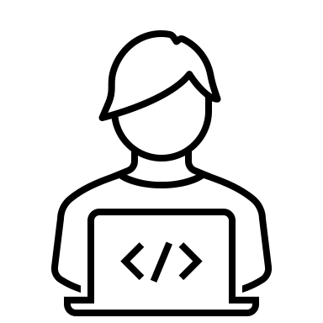
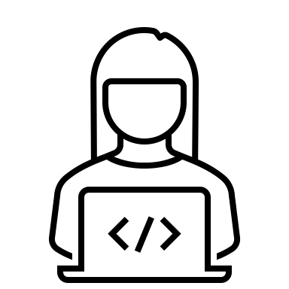

Effective Electronic Public Meetings – Part 2

Advanced Issues

March 5, 2021– 10:00 to 11:00 am

Our panel includes moderator Philip Freeburg and panelists, Paul Ferguson, Assistant Attorney General, Wisconsin Department of Justice, Open Government and Andrew T. Phillips, Attorney, von Briesen & Roper, S.C., outside general counsel for the Wisconsin Counties Association, will address specific electronic meeting issues through a question and answer approach, including
- Recording meetings
- Special Open Meetings Challenges of the Virtual Format
- Hearings - What Can and Cannot be Done
  - Can you conduct a remote evidentiary hearing?
- Closed Sessions in a "Virtual" Environment
- Meeting Mix of Electronic vs. In-Person
- Electronic Meeting Lessons Learned

Another presentation feature is your opportunity to ask the panelists an electronic meeting question. If you have a question for the panel, please send them to Daniel.foth@wisc.edu before March 2, 2021.

This webinar's price is $20.00, and please use this LGE registration link to sign up. https://charge.wisc.edu/LocalGovernment/workshop_register.aspx?workshop_id=51. After registering, you will receive an email with a Zoom link that will allow you to complete your webinar registration.

