Social Media Resources

Social Media Informal Video Script for Posting (15 seconds)
[Greeting, I’m [name]. Happy Public Service Recognition Week 2023! At [organization], I serve the public by [role or tasks]. [Name or organization], how do you serve the public? Spread the word: like, share and tag this post #PSRW [Tags]

Limited Character Social Media Post Examples
Example 1: Join me in honoring our employees [and volunteers] [and others] during Public Service Recognition Week, May 7th-May 13th. Thank you for your dedicated service! #PSRW [Tags]

Example 2: Public Service Recognition Week is May 7th-May 13th.Thank you to our dedicated employees [and volunteers] [and others]. #PSRW [Tags]

Facebook Cover
Download Link
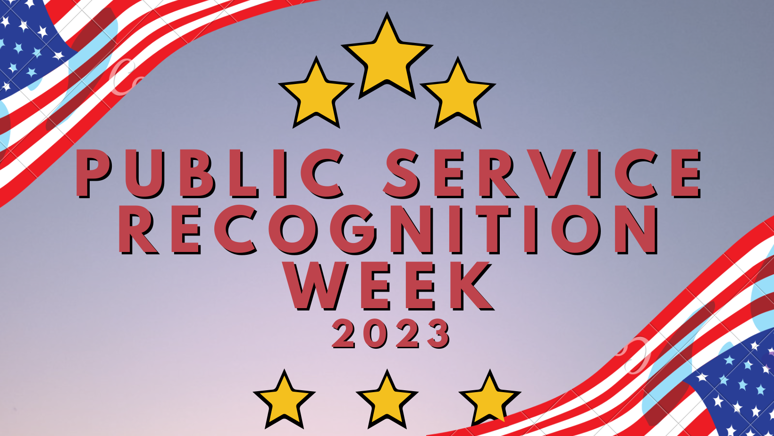

LinkedIn Banner
Download Link

Website Banner
Download Link

